SECO leaf traits protocol

John L. Godlee, Mathew Rees

Introduction
The purpose of this protocol is to provide a common method for collecting measurements of tree leaf chemistry and leaf mass per area (LMA) from SECO plots. The protocol aims to obtain a community weighted mean of various leaf traits for each plot sampled, as well as information on the mean and variance of trait values for dominant tree species across plots within a site. Data generated using this protocol will be used to constrain models of the terrestrial carbon cycle in dry tropical vegetation.

Equipment
- Coin envelopes – one per individual tree sampled
- 6-10 mm diameter circular hole punch
- Notebook and stationery
- DBH tape measure
- Handheld GPS unit
- Large Ziploc bags
- Sealable plastic containers
- Tree cutting poles
- Silica gel – 250 g per 50 envelopes
- Two A4 Perspex plastic sheets, one white, one transparent
- Scale bar for Perspex plastic sheets
- Compact camera or smartphone
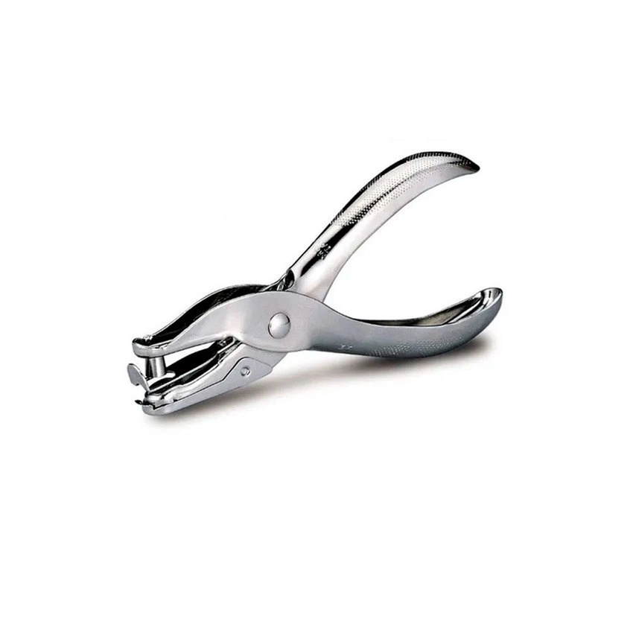
Figure 1: Example of a hole punch used to harvest leaf samples.
Contact John L. Godlee (john.godlee@ed.ac.uk) if you cannot source any of the equipment and we can try to send it by courier.
It is recommended to take extras of all field equipment, especially the hole punch, in case of breakages.

Sampling strategy
For each plot, sample the most dominant tree species, comprising ≥80% of the basal area in the plot. For each tree species, sample five individuals. Trees within each species should be sampled across a range of basal areas. For trees with multiple stems, calculate tree basal area as the sum of basal areas across all stems.
As the leaf trait sampling relies on knowing the basal area contribution of each species in the plot, tree stem data comprising at least species identity and stem diameter (DBH, diameter at breast height) must already exist.
R code is provided with this protocol to automate the identification of the dominant species per plot, and to create a stratified sample of individuals per species according to tree basal area.

Field method
Use a handheld GPS unit to record the location of each plot where leaf traits will be sampled.
Use tree cutting poles to collect 5 small branches from each sampled tree. Sample branches at different heights in the canopy. Avoid epicormic growth where possible, i.e. juvenile growth that flushes from immediately under the bark, often after a branch has broken and is regrowing.
From each branch, collect one fully expanded and undamaged leaf. Avoid diseased leaves, leaves damaged by herbivores, and senescing leaves.
For each individual, label a coin envelope with the following:
- Site name
- Plot name
- Tag ID of tree
- Species of tree
- Date collected
- Name of collector
Press leaves between perspex sheets and photograph with the scale bar and labelled coin envelope, to record leaf area. Ensure the photo is taken looking directly down onto the leaf, not at an angle. Alternatively, use a flatbed scanner connected to a laptop to speed up the process. Leaves must be photographed when fresh, as dried leaves become brittle and can roll up. A printable scale bar is provided with this protocol. Print the scale bar specifying that the image size is 4x6 inch. Double check the scale is the correct size before taking to the field. Consider laminating, printing on heavy card stock, or mounting the scale bar to make it more robust.
From each leaf, collect 10 leaf punches. Avoid prominent veins and the leaf midrib where possible. For compound leaves, collect punches across many leaflets. If the leaf is too small to collect 10 leaf punches, sample more leaves from the same branch until 10 leaf punches have been collected. Ensure all punches are the full size of the punch.
If leaves or leaflets are too small for the hole punch, sample whole leaves. Try to sample ≥3 cm² of leaf material per branch, across five branches per individual. Record this by adding a large ‘*’ to the envelope.
Be sure to identify whether a leaf is a compound leaf with multiple leaflets. Sample entire leaves.
Combine leaf punches from a single individual in one coin envelope. Each envelope should contain 50 punches, 10 from each of 5 leaves.
Combine coin envelopes for a single species into a large Ziploc bag.
On the same day, combine the coin envelopes with silica gel in large Ziploc bags or a sealed plastic container to dry the leaf material. As a general rule, for up to 50 envelopes, each containing up to 10 cm² of leaf material, add 250 g of silica gel. Leaf material should dry within 2-3 days, after which the envelopes can be moved to another sealed container with less silica gel.

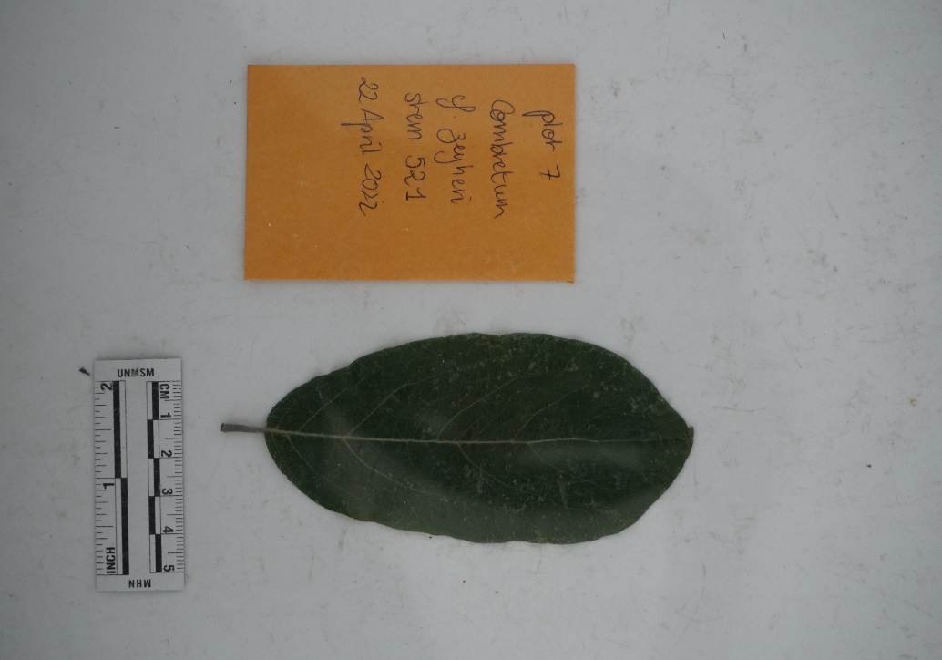
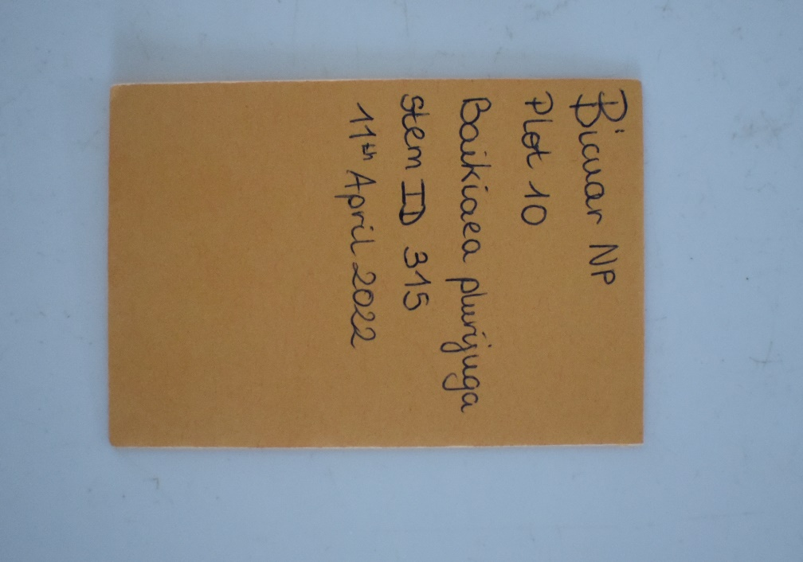
Figure 2: Example of a leaf photograph under perspex with scale bar and labelled coin envelope, to estimate leaf area. Close up of labelled coin envelope.

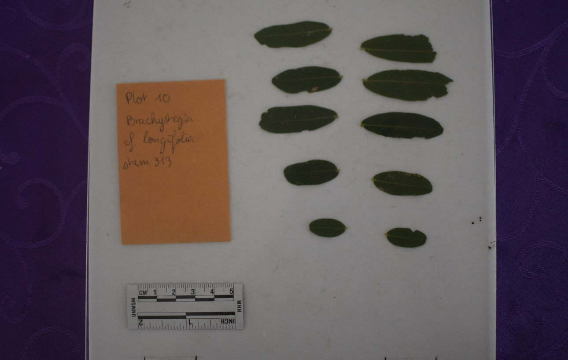
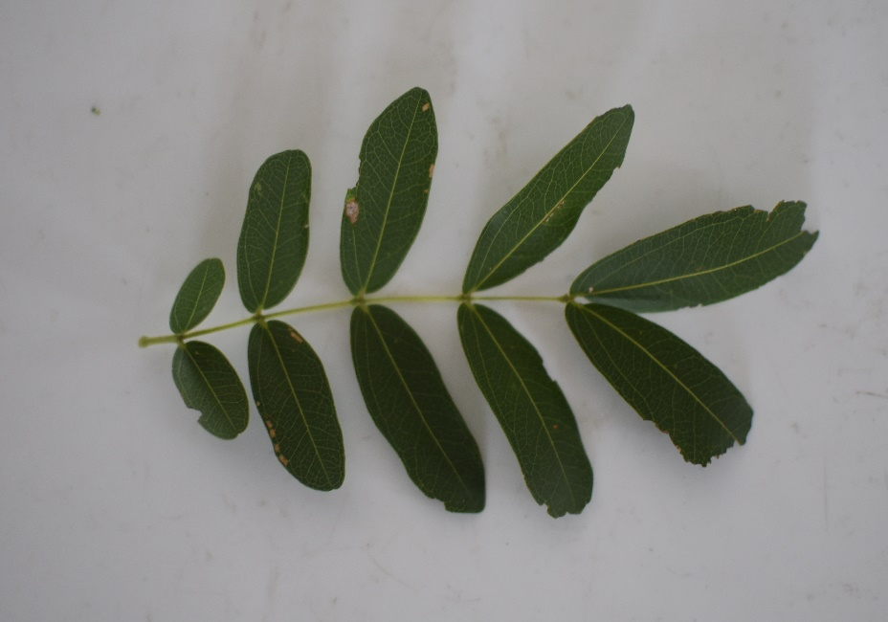
Figure 3: A compound leaf of Brachystegia cf. longifolia, and the same leaf with leaflets stripped to calculate leaf area.

Transport
Specimens should be sent to The University of Edinburgh for further analysis.
The address to send specimens is:
Dr. Kyle Dexter
Crew Building
Alexander Crum Brown Road
The King’s Buildings
The University of Edinburgh
Edinburgh
United Kingdom
EH9 3FF
Specimens should be packaged to ensure they remain intact and sealed for the duration of the journey. Specimens should be kept in coin envelopes, with one species per Ziploc bag. Ziploc bags should be placed inside another sealed plastic container or bag, and finally inside a third sealed container. It is recommended to seal plastic containers with cable ties or duct tape.
All packages must be accompanied by a Letter of Authority. This letter must be contained within the package and displayed on the outside to prevent the package being opened at customs. Contact John L. Godlee (john.godlee@ed.ac.uk) for a copy of the letter.
Send leaf photos to John L. Godlee (john.godlee@ed.ac.uk) for leaf area analysis. If there is interest, I can provide guidance on estimating leaf area using the ImageJ software package.

